

Car Pooling

Design Document Software Engineering



April 5, 2013

Lahore University of management Sciences

DHA Lahore Cant, Lahore, Pakistan.

Car Pooling

Software Engineering Course Project

Project Design Specification Document



Group 5

Hasan Abbas 2014-10-0059

Muhammad Wajahat 2014-10-0128

Luqman Ghani 2014-10-0180

Usman Zaheer 2014-10-0222

Session 2012-2013

Department of Computer Science

Lahore University of Management Sciences

Lahore

Contents

Project Design Specification Document 3

Use Case Diagram 3

System Architecture 4

System Sequence Diagrams 4

Domain model 5

Sequence diagrams 19

Class diagram 32

(Class Diagram using Entity, Boundary and Control Symbols) 32

(Design Class Diagram with Attributes and Methods ) 33

Collaboration Diagrams 34

State charts 39

DB Schema/ ERD 41

SiteMap 42

Human Interface Design 43

Screens 43

Navigation Flow 55

# Project Design Specification Document

## Use Case Diagram

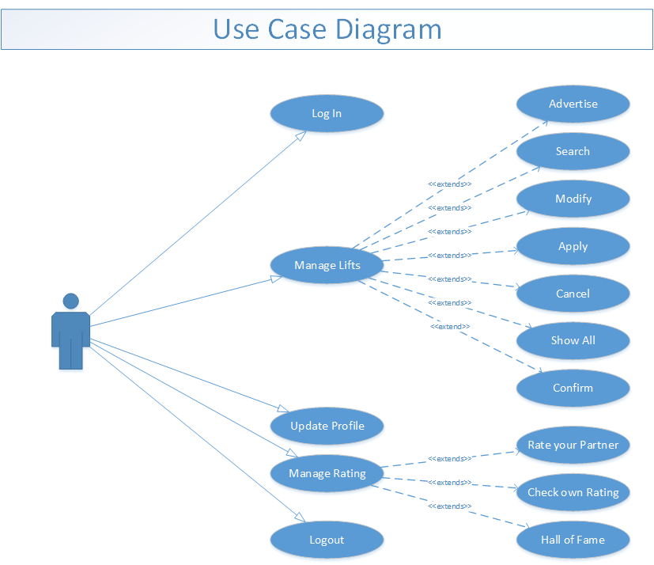

## System Architecture

## 

## System Sequence Diagrams

## 

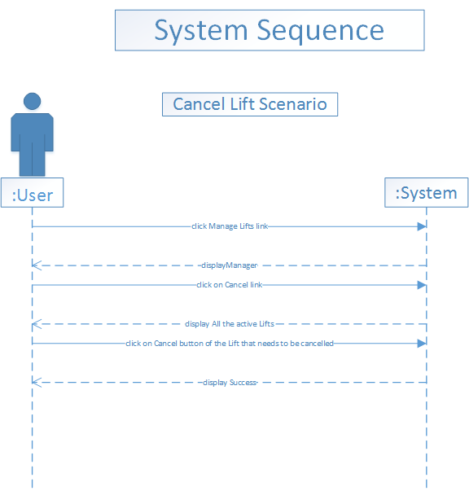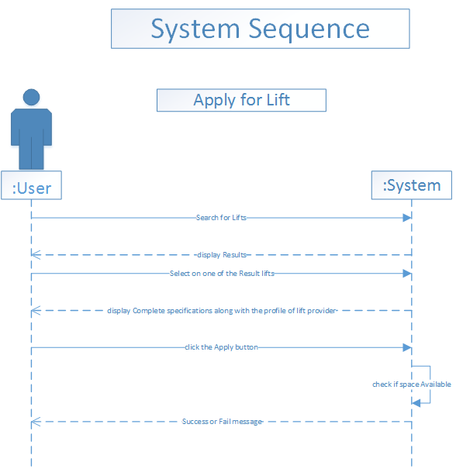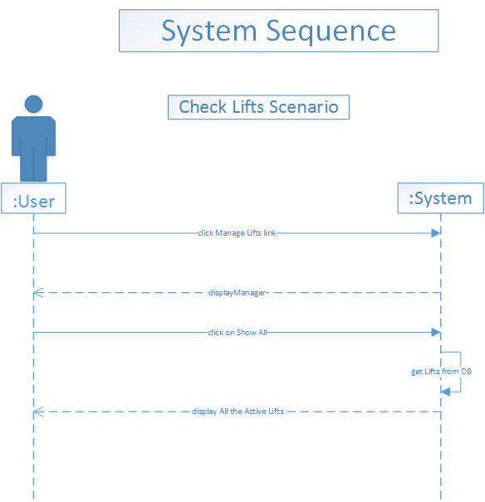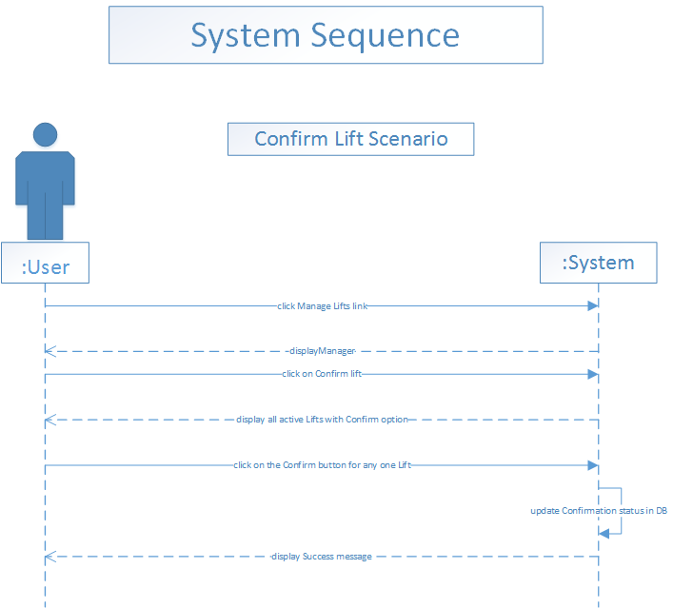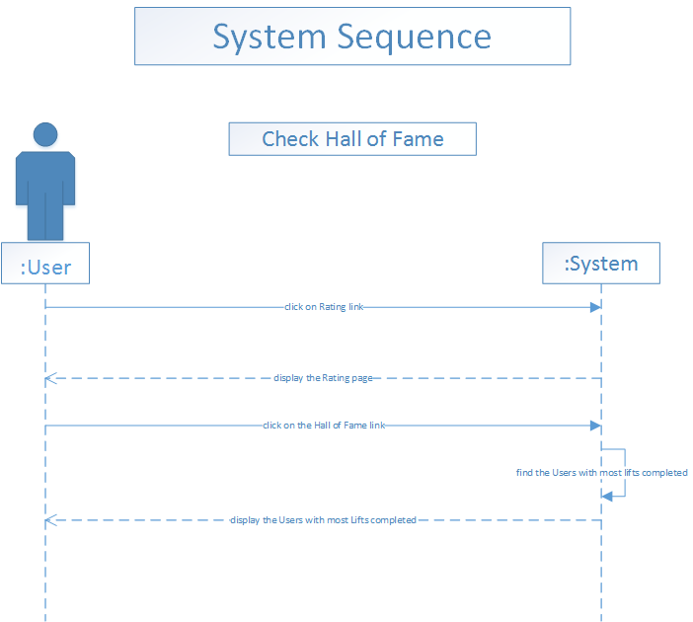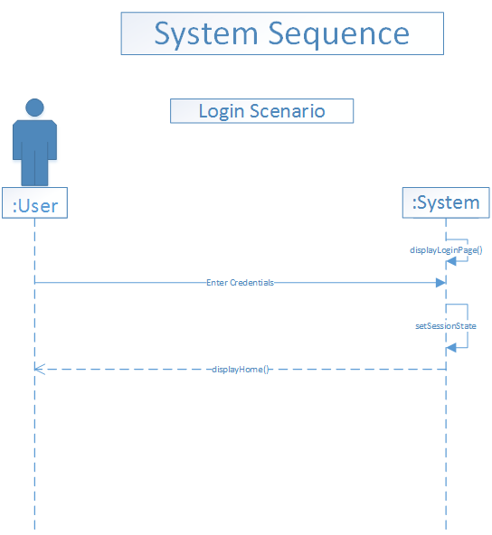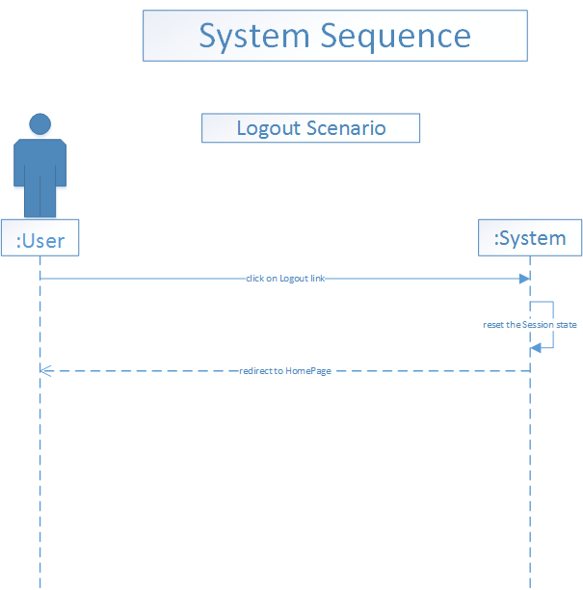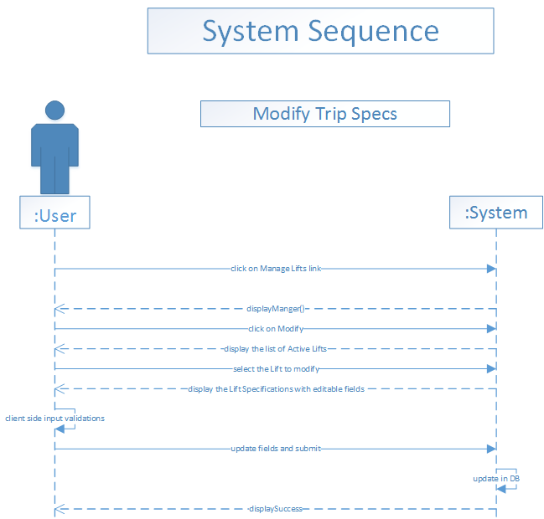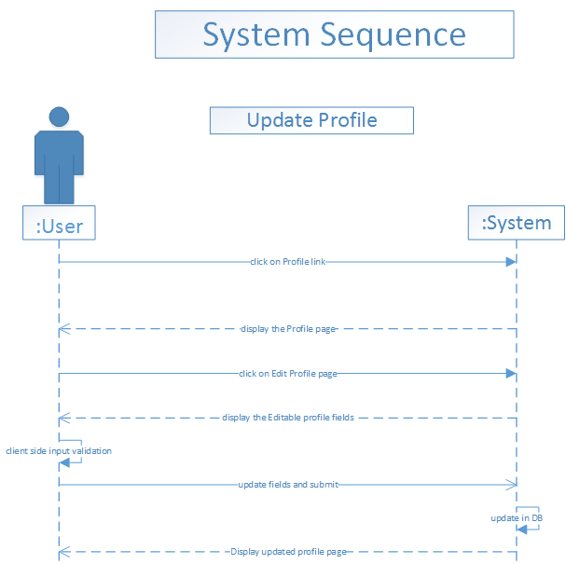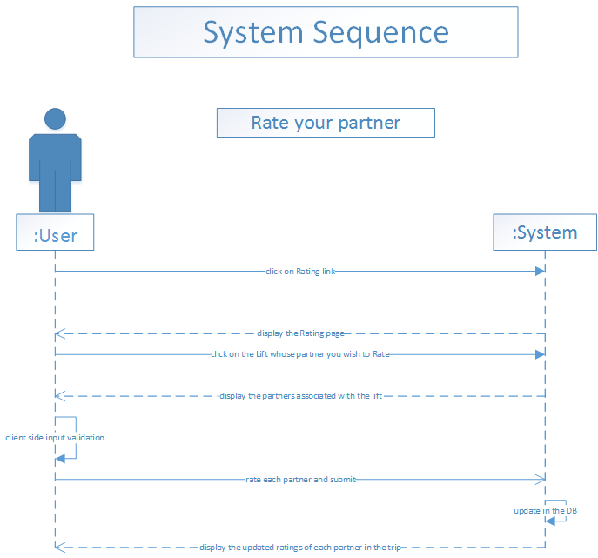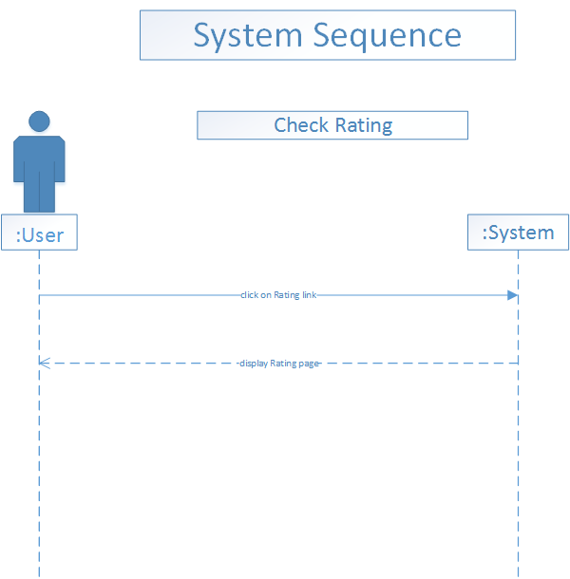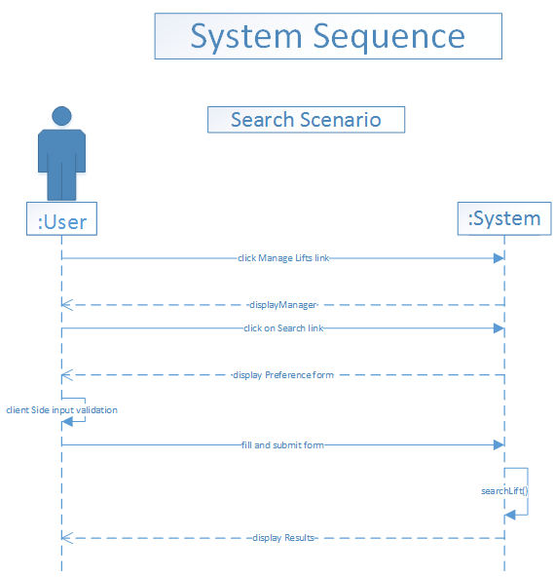

## Domain model

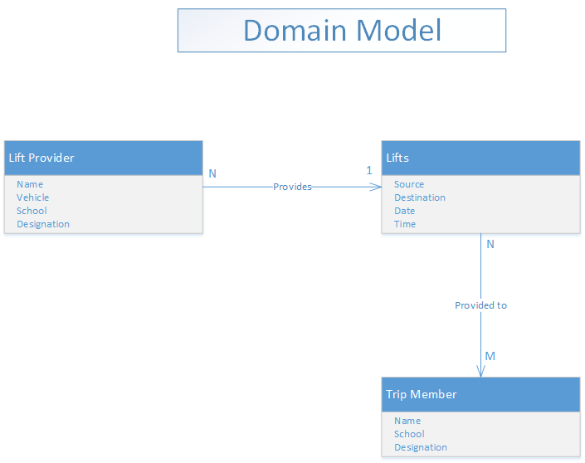

## Sequence diagrams

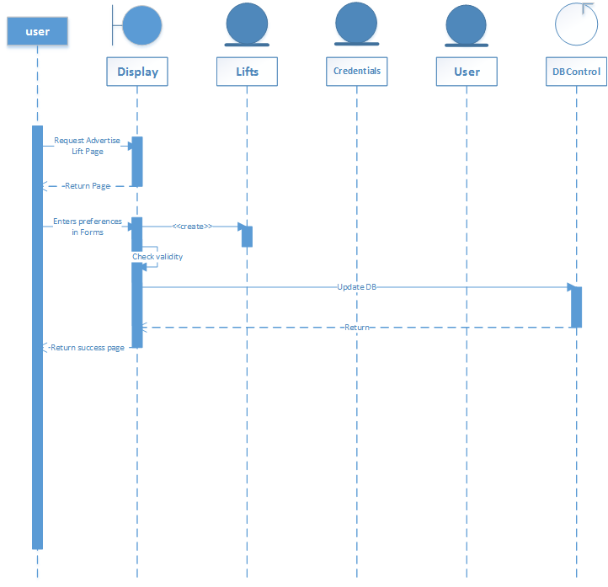

Figure Add Lift

## 

Figure Apply for Lift

## 

Figure Cancel lift

## 

Figure Check own Lifts

## 

Figure Check Rating

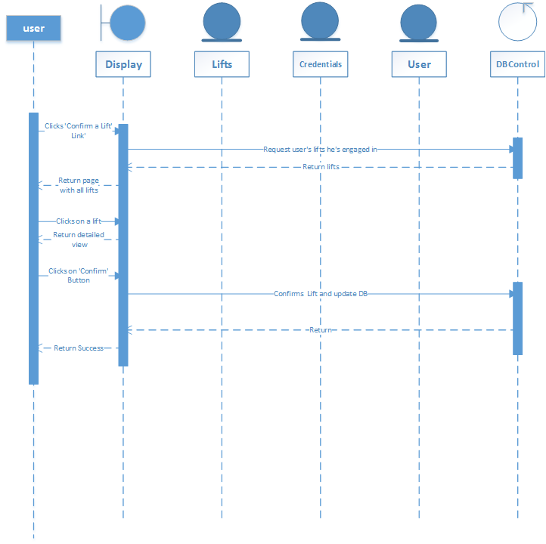

Figure Confirm Lift

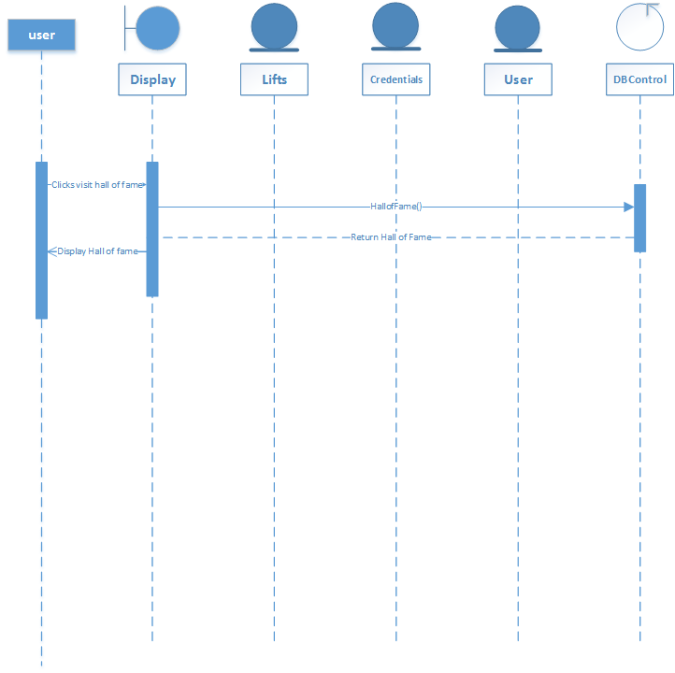

Figure Hall Of Fame

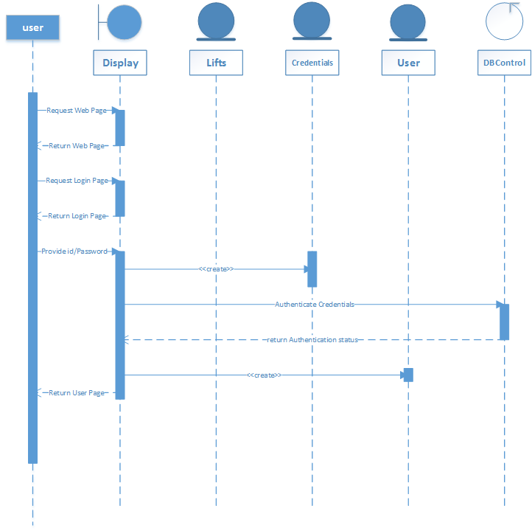

Figure Login

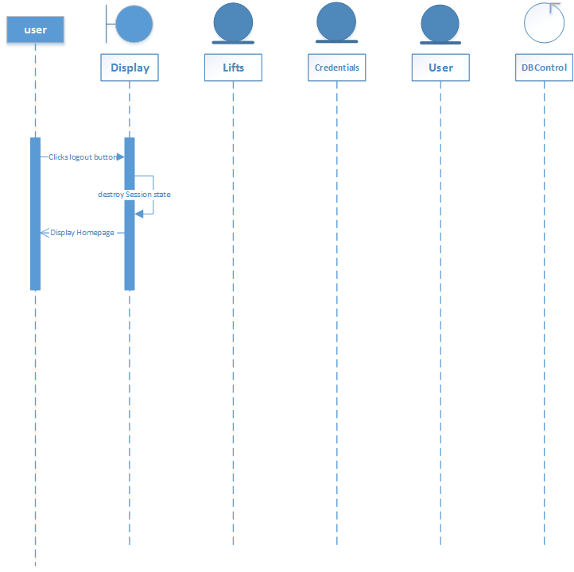

Figure Logout

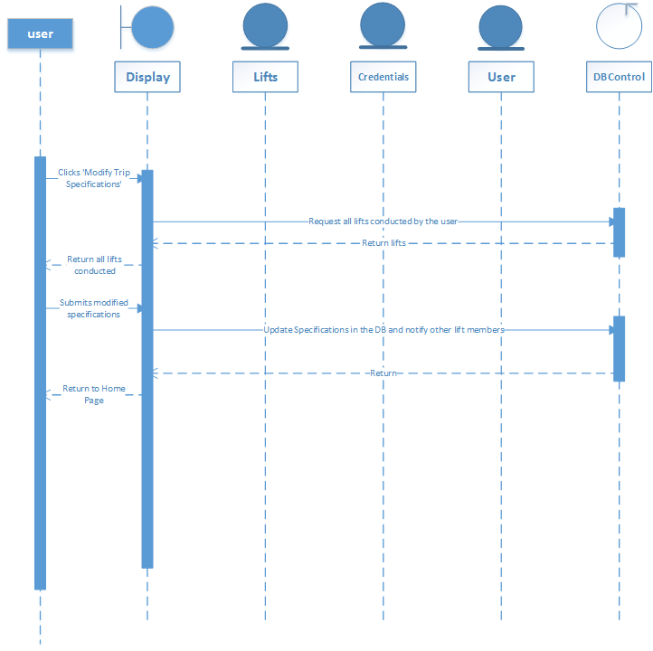

Figure Modify Trip

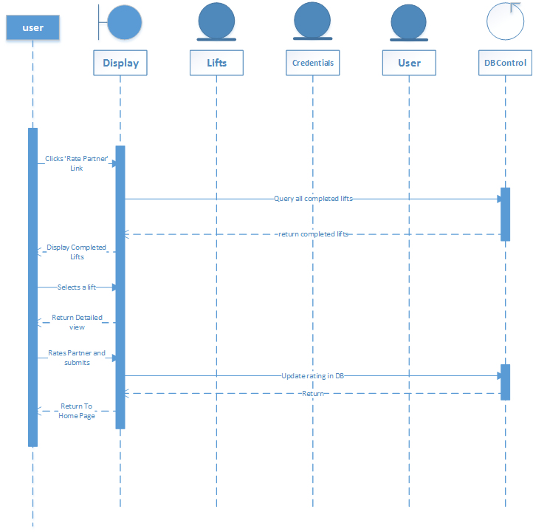

Figure Rate Partner

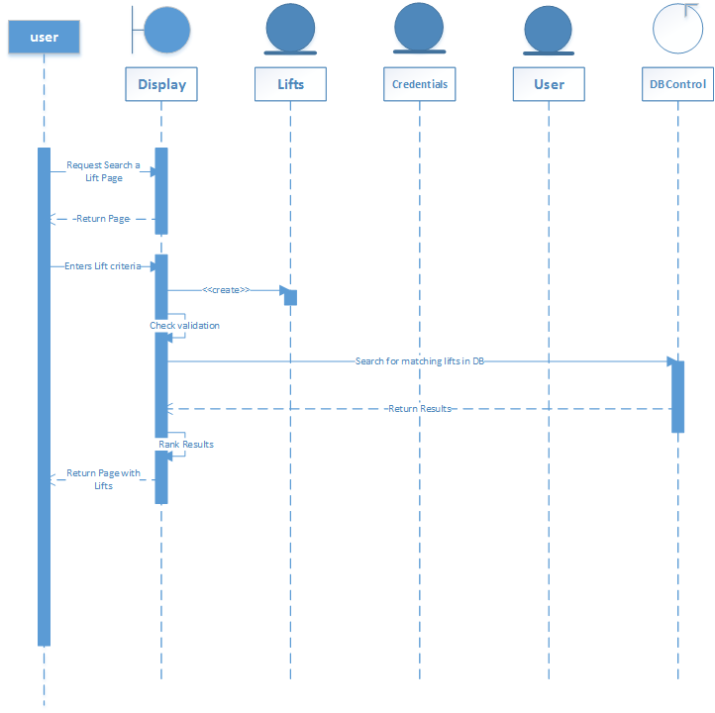

Figure Search Lift

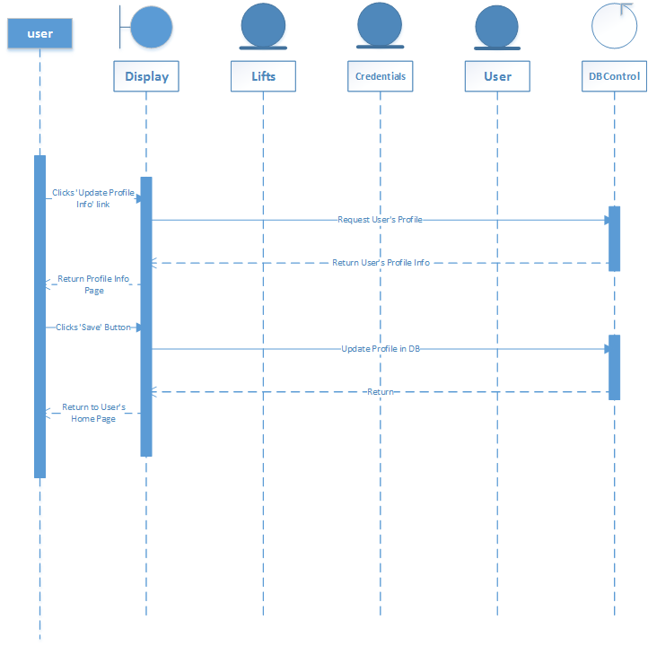

Figure Update Profile

## Class diagram

### Class Diagram using Entity, Boundary and Control Symbols

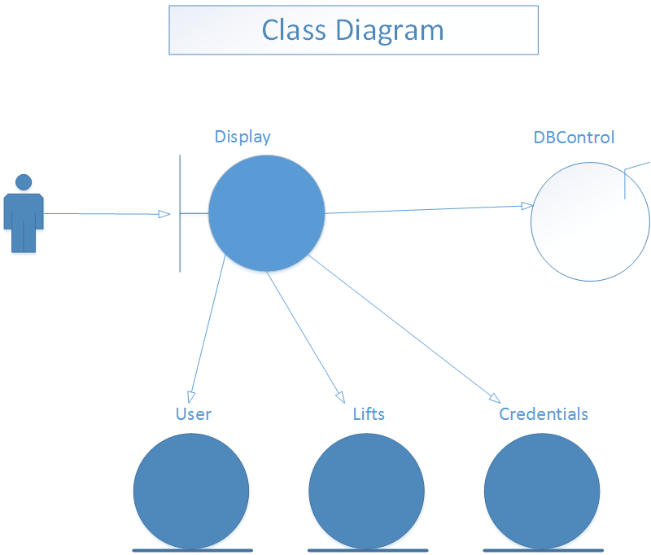

### 

### Design Class Diagram with Attributes and Methods

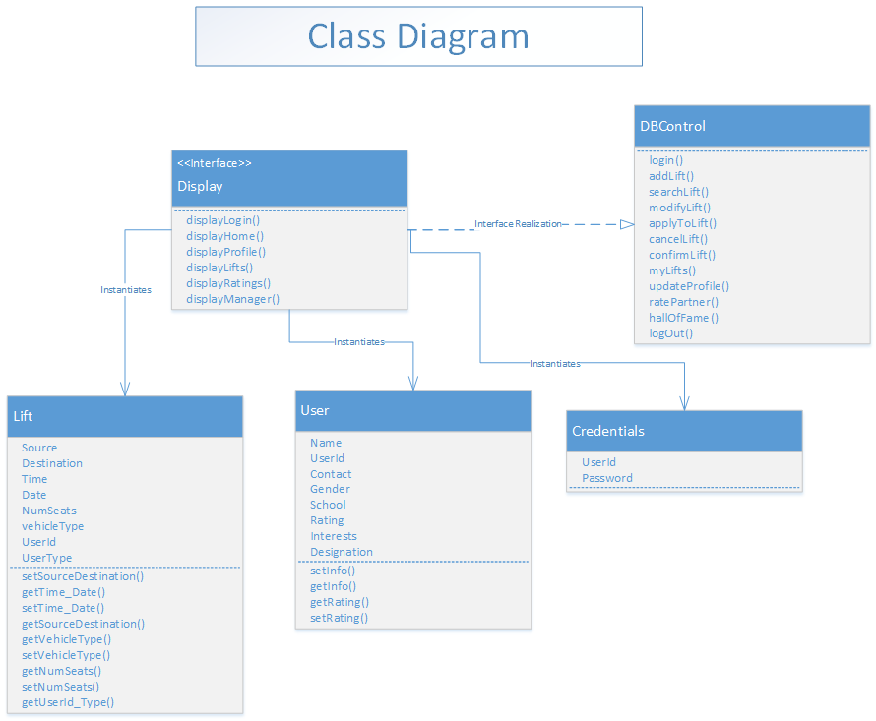

## Collaboration Diagrams

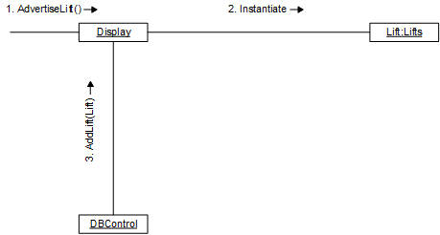

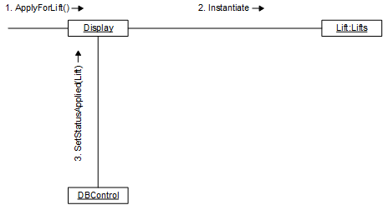

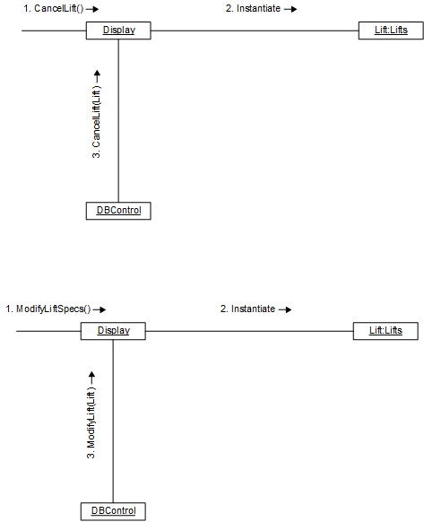

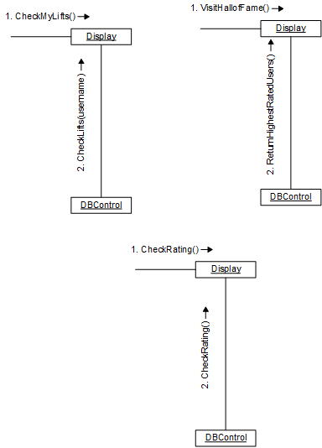

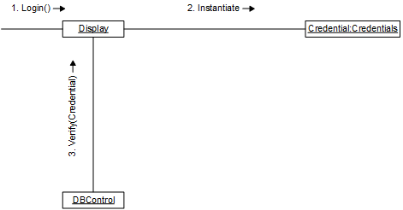

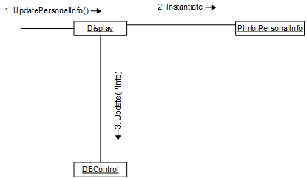

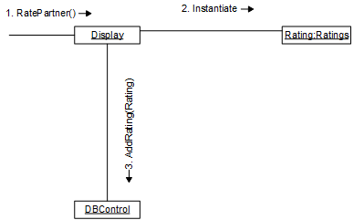

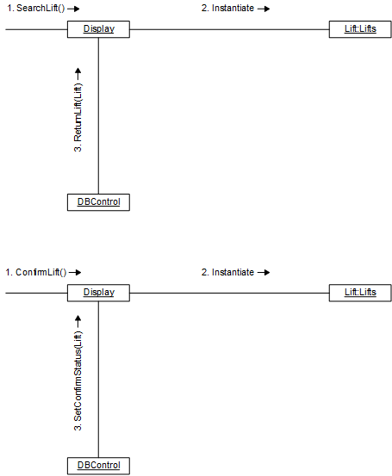

## State charts

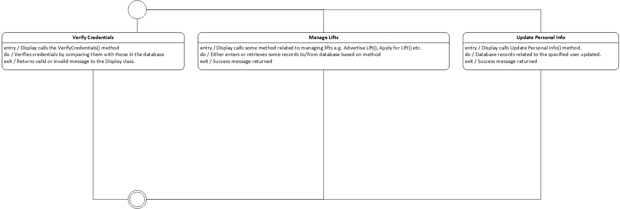

Figure DB Control State Diagram

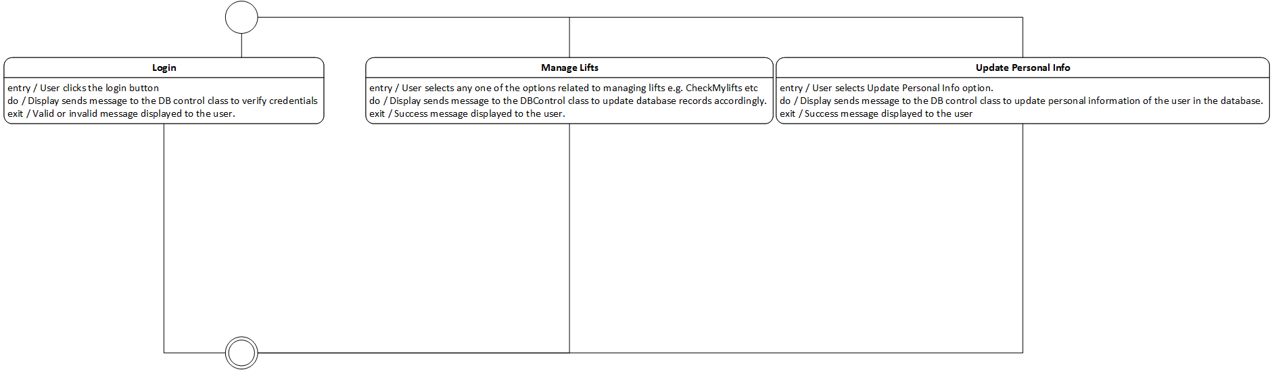

Figure Display State Diagram

The State Diagrams of other Classes are trivial and hence not displayed.

## DB Schema/ ERD

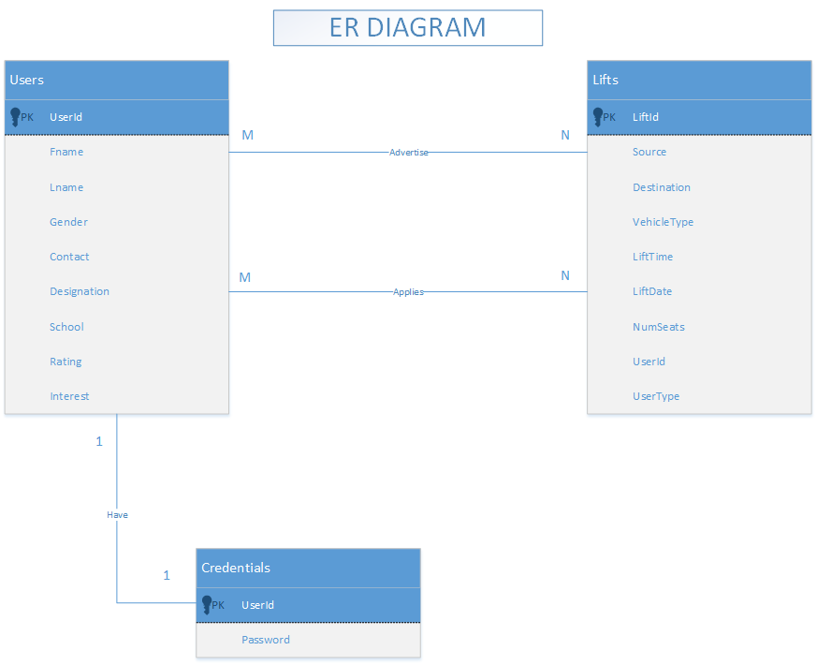

## SiteMap

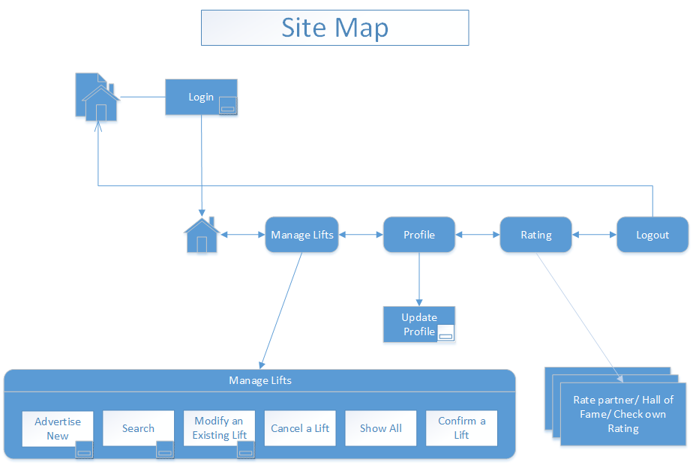

## Human Interface Design

### Screens

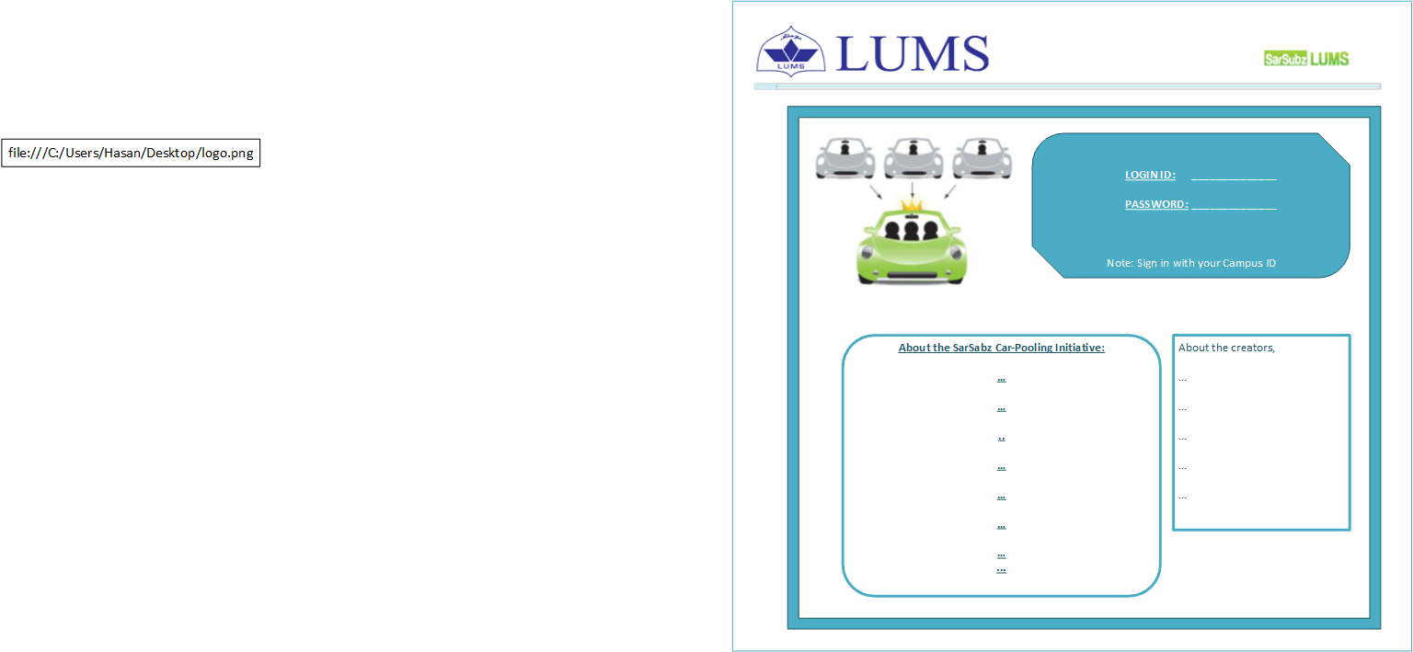

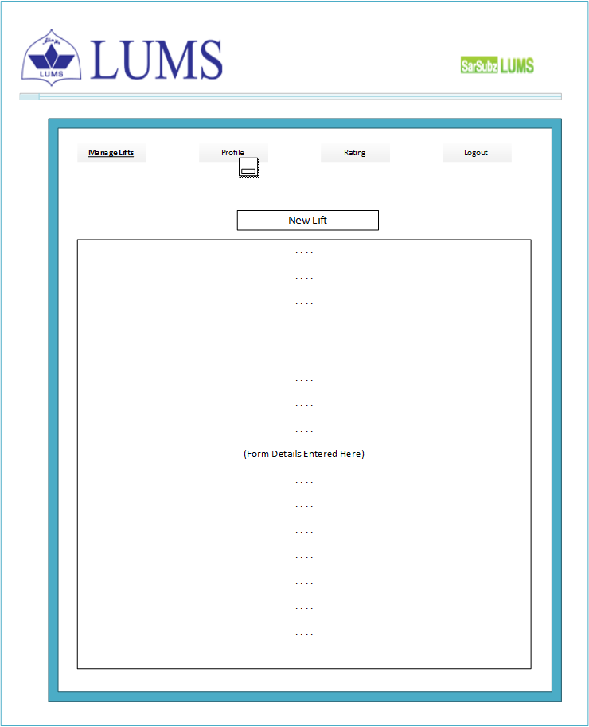

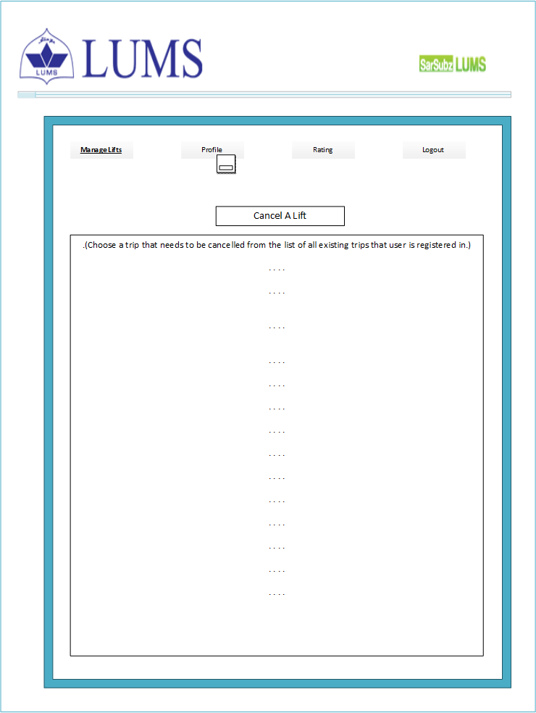

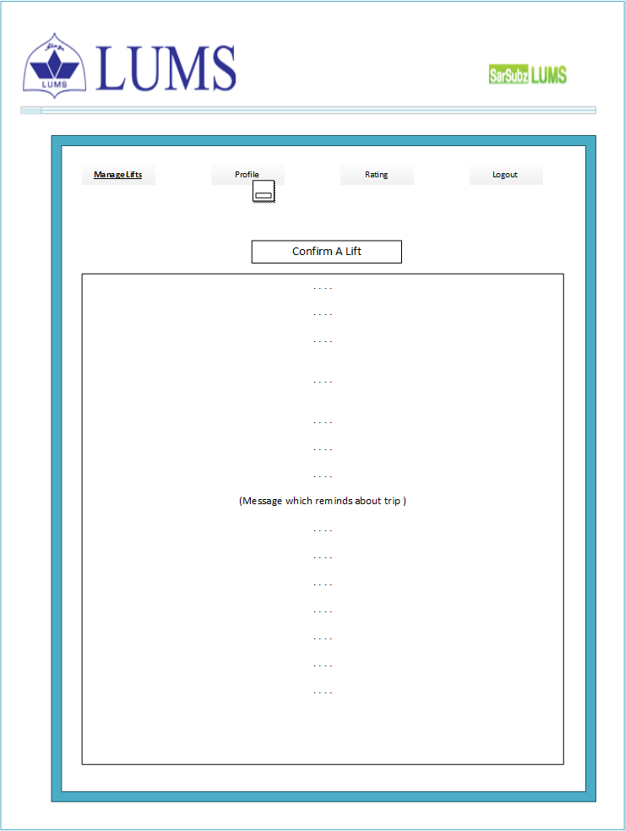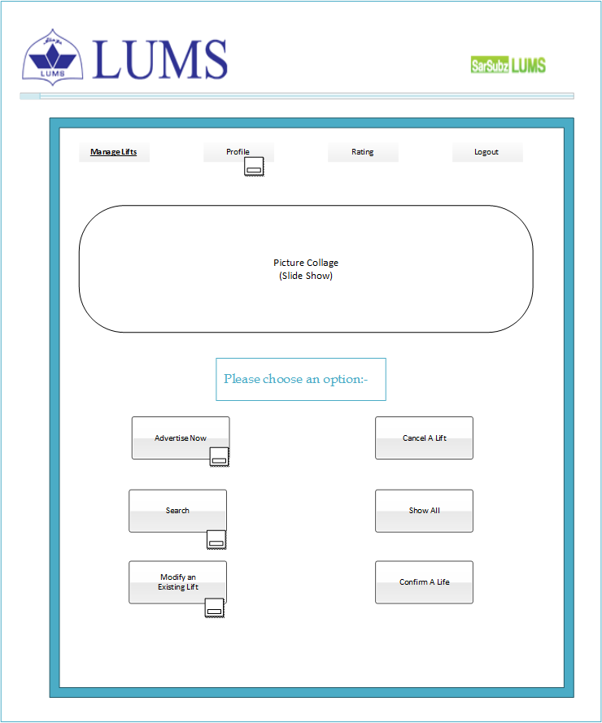

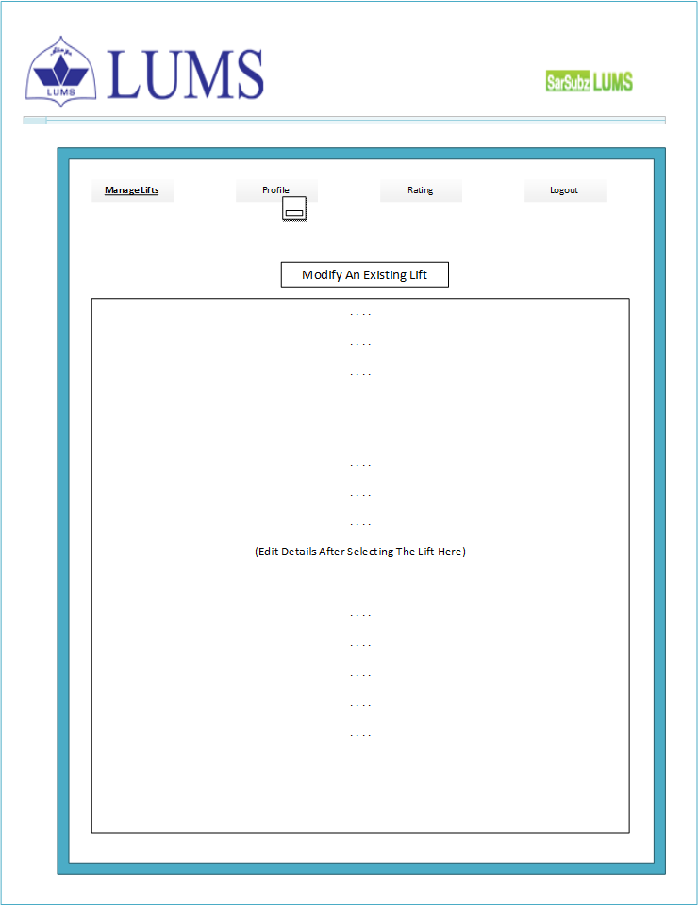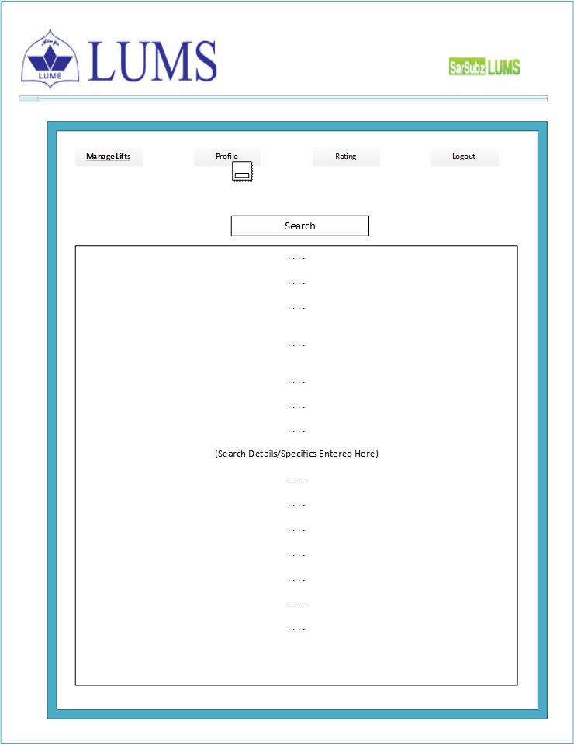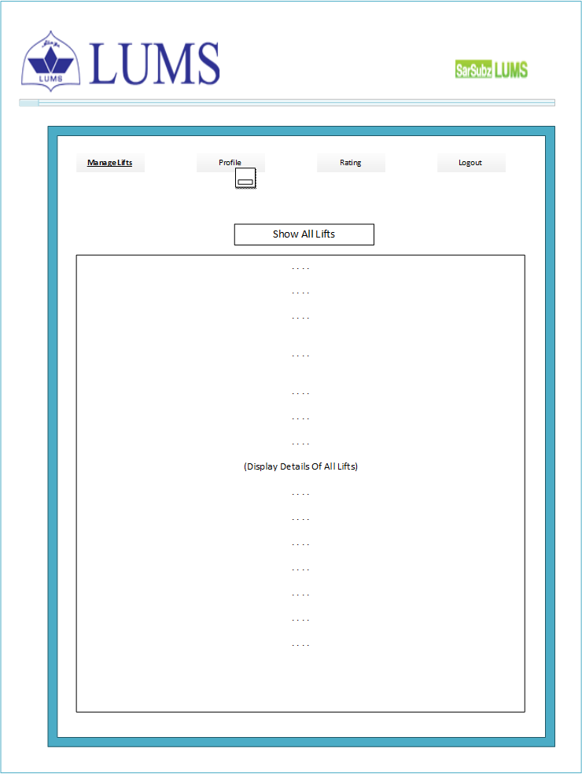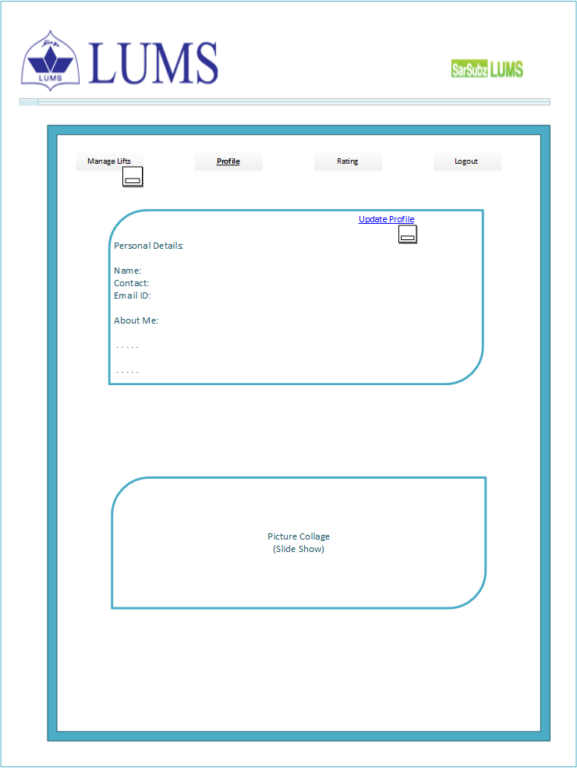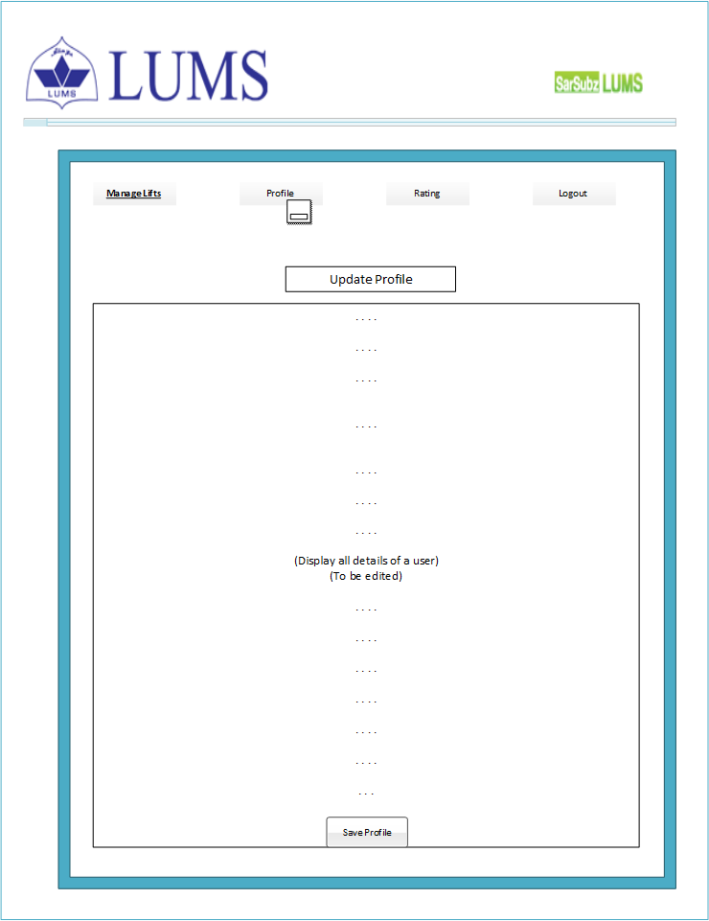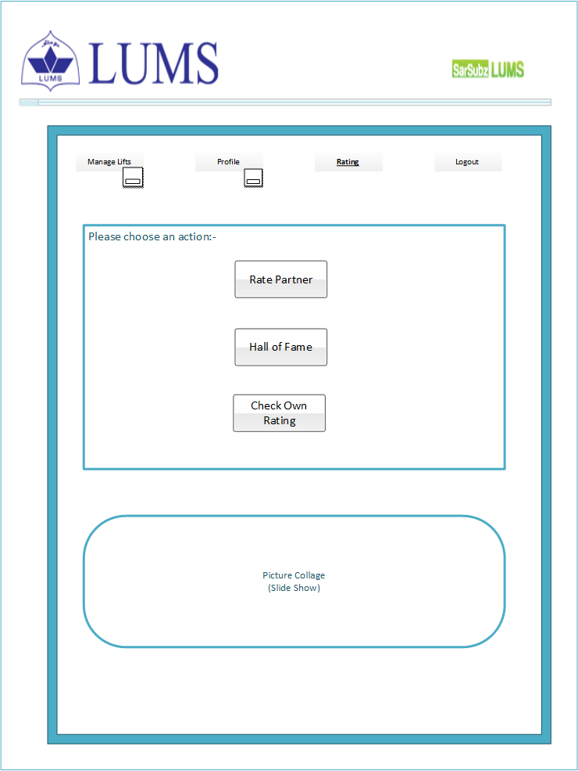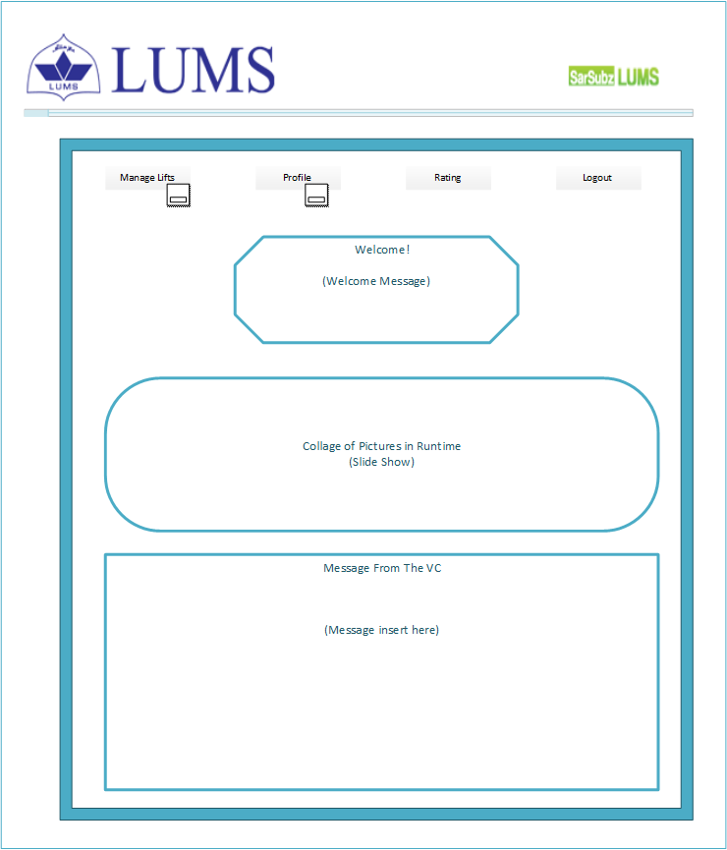

### Navigation Flow

